Length-check LATEX template for preparing an article for submission to Optica Publishing Group journals AO, JOCN, JOSA A, JOSA B, OL, *Optica*, *Optica Quantum*, and PRJ

**AUTHOR ONE**1,2,3 **, AUTHOR TWO**2,* **, AND AUTHOR THREE**1

1*Publications Department, Optica Publishing Group, 2010 Massachusetts Avenue NW, Washington DC, 20036*

2*School of Science, University of Technology, 2000 J St. NW, Washington DC, 20036*

3*School of Optics, University of Technology, 2000 J St. NW, Washington DC, 20036*

*[*email@my-email.com*](mailto:email@my-email.com)

*Compiled September 8, 2023*

**This template can be used to approximate final page** 19 **count for submission to Optica Publishing Group’s jour- nals *Applied Optics*, *Journal of Optical Communications*** 20 ***and Networking*, JOSA A, JOSA B, *Optics Letters*, *Op- tica*, *Optica Quantum*, and *Photonics Research*. Use the shortarticle/true option for *Optics Letters* and short *Op-*** 24

21

22

23

1 ***tica* articles. Authors may also** [**submit articles**](https://opticaopen.org/) **prepared**

**using this template to the Optica Publishing Group preprint server,** [**Optica Open**](https://preprints.opticaopen.org/)**. However, doing so is op- tional. Please refer to the submission guidelines found there. Note that copyright and licensing information should no longer be added to your Journal or Optica Open manuscript.**

25

26

2 <http://dx.doi.org/10.1364/ao.XX.XXXXXX>

# 3. FIGURES AND TABLES

Do not place figures and tables at the back of the manuscript. Figures and tables should be placed and sized as they are likely to appear in the final article.

Figures and Tables should be labelled and referenced in the standard way using the \label{} and \ref{} commands.

1. **Sample Figure**

Figure 1 shows an example figure.

3

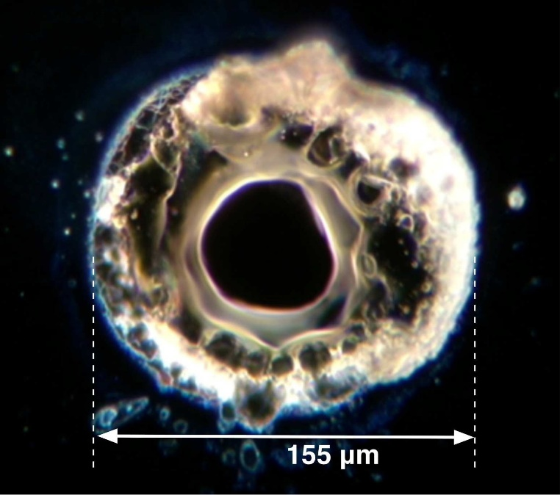

4 **1. INTRODUCTION**

5 See [Style Guide](https://opg.optica.org/submit/templates/default.cfm) and [Manuscript Templates](https://opg.optica.org/submit/templates/default.cfm) pages for more de-

6 tails.

7 If you have a question while using this template on Overleaf,

8 please use the help menu (“?”) on the top bar to search for help

9 or ask us a question using our [contact form](https://www.overleaf.com/contact).

10 **2. CORRESPONDING AUTHOR**

11 We require manuscripts to identify a single corresponding au-

12 thor. The corresponding author typically is the person who

13 submits the manuscript and handles correspondence through-

14 out the peer review and publication process. If other statements

15 about author contribution and contact are needed, they can be

16 added in addition to the corresponding author designation.

17 The sections below show examples of different article compo- 27

18 nents. 28

**Fig. 1.** Dark-field image of a point absorber.

1. **Sample Table**

Table 1 shows an example table.

## Table 1. Shape Functions for Quadratic Line Elements

local node *{N}m {*Φ*i}m* (*i* = *x*, *y*, *z*)

*m* = 1 *L*1(2*L*1 *−* 1) Φ*i*1

*m* = 2 *L*2(2*L*2 *−* 1) Φ*i*2

*m* = 3 *L*3 = 4*L*1 *L*2 Φ*i*3

29 **4. SAMPLE EQUATION**

30 Let *X*1, *X*2, . . . , *Xn* be a sequence of independent and identically

31 distributed random variables with E[*Xi* ] = *µ* and Var[*Xi* ] =

32 *σ*2 < ∞, and let

*S X*1 + *X*2 + *· · ·* + *Xn* 1 *n X*

## (1)

*n* = *n* = *n* ∑ *i*

*i*

33 denote their m*√*ean. Then as *n* approaches infinity, the ran- 62

**Fig. 2.** Terahertz focusing metalens.

1. **Sample Code Citation**

34 dom variables

*−*

35 *N* (0, *σ*2).

*n*(*Sn µ*) converge in distribution to a normal

63

64

65

2. C. Rivers, "Epipy: Python tools for epidemi- ology," Figshare (2014) [retrieved 13 May 2015], [http://dx.doi.org/10.6084/m9.figshare.1005064.](http://dx.doi.org/10.6084/m9.figshare.1005064)

36 **5. SAMPLE ALGORITHM**

37 Algorithms can be included using the commands as shown in 66

38 algorithm 1.

67

68

**Algorithm 1.** Euclid’s algorithm 69

1: **procedure** EUCLID(*a*, *b*) ▷ The g.c.d. of a and b 70

2: *r a* mod *b* 71

*←*

3: **while** *r* = 0 **do** ▷ We have the answer if r is 0 72

*̸*

4: *a b* 73

*←*

5: *b r* 74

*←*

6: *r a* mod *b* 75

*←*

7: **return** *b* ▷ The gcd is b 76

# 6. BACKMATTER

Backmatter sections should be listed in the order Fund- ing/Acknowledgment/Disclosures/Data Availability State- ment/Supplemental Document section. An example of back- matter with each of these sections included is shown below.

**Funding.** Content in the funding section will be generated entirely from details submitted to Prism. Authors may add placeholder text in the manuscript to assess length, but any text added to this section in the manuscript will be replaced during production and will display official funder names along with any grant numbers provided. If additional details about a funder are required, they may be added to the Acknowl-

77

78

79

edgments, even if this duplicates information in the funding section. See the example below in Acknowledgements. For preprint submissions, please include funder names and grant numbers in the manuscript.

39 **A. Supplementary materials in Optica Publishing Group jour-**

40 **nals**

41 Optica Publishing Group journals allow authors to include sup-

42 plementary materials as integral parts of a manuscript. Such

43 materials are subject to peer-review procedures along with the

44 rest of the paper and should be uploaded and described using

45 the Prism manuscript system. Please refer to the [Author Guide-](https://opg.optica.org/submit/style/supplementary_materials.cfm)

46 [lines for Supplementary Materials in Optica Publishing Group](https://opg.optica.org/submit/style/supplementary_materials.cfm)

47 [Journals](https://opg.optica.org/submit/style/supplementary_materials.cfm) for more detailed instructions on labeling supplemen-

48 tary materials and your manuscript. For preprints submitted to

49 Optica Open a link to supplemental material should be included

50 in the submission, but do not upload the material.

## 51 Authors may also include Supplemental Documents (PDF

52 documents with expanded descriptions or methods) with the

53 primary manuscript. At this time, supplemental PDF files are

54 not accepted for JOCN or PRJ. To reference the supplementary

55 document, the statement “See Supplement 1 for supporting con-

56 tent.” should appear at the bottom of the manuscript (above the

57 References heading). Supplemental documents are not accepted

58 for Optica Open preprints.

59 **B. Sample Dataset Citation**

60 1. M. Partridge, "Spectra evolution during coating," figshare

61 (2014), [http://dx.doi.org/10.6084/m9.figshare.1004612.](http://dx.doi.org/10.6084/m9.figshare.1004612)

80

81

82

83

84

85

86

87

88

89

90

91

92

93

94

95

96

97

98

99

100

101

102

103

**Acknowledgments.** The section title should not follow the number- ing scheme of the body of the paper. Additional information crediting individuals who contributed to the work being reported, clarifying who received funding from a particular source, or other information that does not fit the criteria for the funding block may also be included; for example, “K. Flockhart thanks the National Science Foundation for help identifying collaborators for this work.”

**Disclosures.** Disclosures should be listed in a separate section at the end of the manuscript. List the Disclosures codes identified on the [Conflict of Interest policy page](https://opg.optica.org/submit/review/conflicts-interest-policy.cfm). If there are no disclosures, then list “The authors declare no conflicts of interest.”

Here are examples of disclosures:

**Disclosures.** ABC: 123 Corporation (I,E,P), DEF: 456 Corporation (R,S). GHI: 789 Corporation (C).

**Disclosures.** The authors declare no conflicts of interest.

**Data Availability Statement.** A Data Availability Statement (DAS) will be required for all submissions beginning 1 March 2021. The DAS should be an unnumbered separate section titled “Data Availability” that immediately follows the Disclosures section. See the [Data Availability](https://opg.optica.org/submit/review/data-availability-policy.cfm) [Statement policy page](https://opg.optica.org/submit/review/data-availability-policy.cfm) for more information.

There are four common (sometimes overlapping) situations that authors should use as guidance. These are provided as minimal models, and authors should feel free to include any additional details that may be relevant.

104 1. When datasets are included as integral supplementary material in

105 the paper, they must be declared (e.g., as "Dataset 1" following our

106 current supplementary materials policy) and cited in the DAS, and

107 should appear in the references.

108 **Data availability.** Data underlying the results presented in this

109 paper are available in Dataset 1, Ref. [3].

110 2. When datasets are cited but not submitted as integral supplemen-

111 tary material, they must be cited in the DAS and should appear in

112 the references.

113 **Data availability.** Data underlying the results presented in this

114 paper are available in Ref. [3].

115 3. If the data generated or analyzed as part of the research are not

116 publicly available, that should be stated. Authors are encouraged

117 to explain why (e.g. the data may be restricted for privacy reasons),

118 and how the data might be obtained or accessed in the future.

119 **Data availability.** Data underlying the results presented in this

120 paper are not publicly available at this time but may be obtained

121 from the authors upon reasonable request.

122 4. If no data were generated or analyzed in the presented research,

123 that should be stated.

124 **Data availability.** No data were generated or analyzed in the

125 presented research.

126 Data availability statements are not required for preprint submissions.

127 **Supplemental document.** See Supplement 1 for supporting content.

128 **7. REFERENCES**

129 Note that *Optics Letters* and *Optica* short articles use an abbrevi-

130 ated reference style. Citations to journal articles should omit the

131 article title and final page number; this abbreviated reference

132 style is produced automatically when the *Optics Letters* journal

133 option is selected in the template, if you are using a .bib file for

134 your references.

135 Add citations manually or use BibTeX. See [1–5]. List up to three

136 author names in references, and if there are more than three

137 authors use *et al.* after that.

138 **REFERENCES**

139 1. Y. Zhang, S. Qiao, L. Sun, *et al.*, Opt. Express **22**, 11070 (2014).

140 2. Optica Publishing Group, “Optica,” [https://opg.optica.org](https://opg.optica.org/).

141 3. P. Forster, V. Ramaswamy, P. Artaxo, *et al.*, “Changes in atmospheric

142 consituents and in radiative forcing,” in *Climate Change 2007: The*

143 *Physical Science Basis. Contribution of Working Group 1 to the Fourth*

144 *assesment report of Intergovernmental Panel on Climate Change,*

145 S. Solomon, D. Qin, M. Manning, *et al.*, eds. (Cambridge University

146 Press, 2007).

147 4. R. McKay, “X-ray crystallography,” Ph.D. thesis, Princeton University

148 (1982).

149 5. V. S. C. Manga Rao and S. Hughes, Phys. Rev. B **75** (2007).

150 **FULL REFERENCES**

151 1. Y. Zhang, S. Qiao, L. Sun, *et al.*, “Photoinduced active terahertz meta-

152 materials with nanostructured vanadium dioxide film deposited by sol-

153 gel method,” Opt. Express **22**, 11070–11078 (2014).

154 2. Optica Publishing Group, “Optica,” [https://opg.optica.org](https://opg.optica.org/).

155 3. P. Forster, V. Ramaswamy, P. Artaxo, *et al.*, “Changes in atmospheric

156 consituents and in radiative forcing,” in *Climate Change 2007: The*

157 *Physical Science Basis. Contribution of Working Group 1 to the Fourth*

158 *assesment report of Intergovernmental Panel on Climate Change,*

159 S. Solomon, D. Qin, M. Manning, *et al.*, eds. (Cambridge University

160 Press, 2007).

161 4. R. McKay, “X-ray crystallography,” Ph.D. thesis, Princeton University

162 (1982).

163 5. V. S. C. Manga Rao and S. Hughes, “Single quantum-dot Purcell factor

164 and *β* factor in a photonic crystal waveguide,” Phys. Rev. B **75** (2007).